Bubble Sort
The basic operation here is key comparison,
A[j+1]<A[j].
The number of times, the basic operation is executed depends only on the array size and is given by,

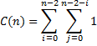
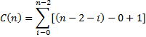
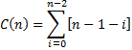

The number of key swaps however, depends on the input. For the worst case, if the elements are in decreasing arrays, it is same as number of key comparisons. Therefore,

